Process to Build the Frequency Schedule for a customer in SQL Database
- Have customer build frequencies in Excel Spreadsheet: : frequency_schedules_import_template.xlsx
- Export Excel data to csv file (screen #1)
- Open ssms (sql server management studio)
  - Delete Table: frequency_schedules_import_template
    - ssms SQL: drop table dbo. frequency_schedules_import_template
  - In ssms Import csv file (screen #2)
    - Right click emar>>Tasks>>Import Flat File
    - Follow Screen #3 through #8
- In ssms run script: frequency_schedules_change_report.sql (Screen #9)
  - This is a report that displays all the changes that will happen during the update
- In ssms run script: frequency_schedules_update_script.sql
  - This display a count of records changes (screen #10)
  - Optionally running this again would return record counts of all 0 because updates have been completed
- Optional run step #4 again there should be no changes left to display in the report

Process to pre-populate Excel with existing customer data
- Open ssms (sql server management studio)
- Open Excel file: frequency_schedules_import_template.xlsx to the TAB: import_data
- Run sql query: change name as required or sort order as preferred
select * from dbo.frequency_schedules_export_view
where site_name='FDB (36)'
order by point_in_time,frequency_type_description
- Right click on the results (Screen #11)
  - Select All
  - Select Copy
  - Paste into Excel under the existing header columns (Screen #12)

Screen #1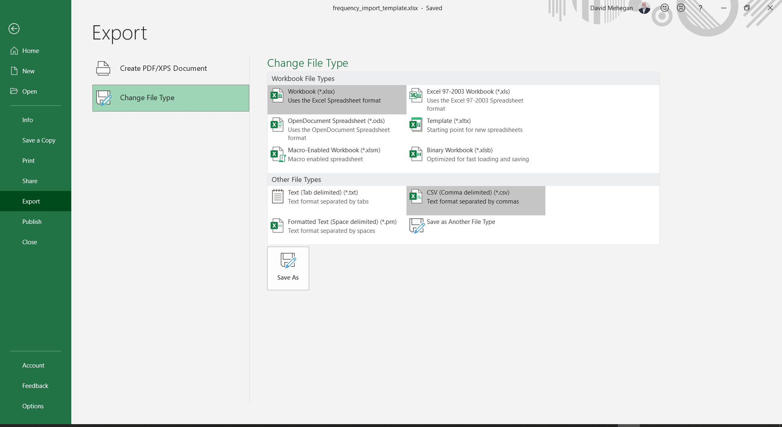

Screen #2
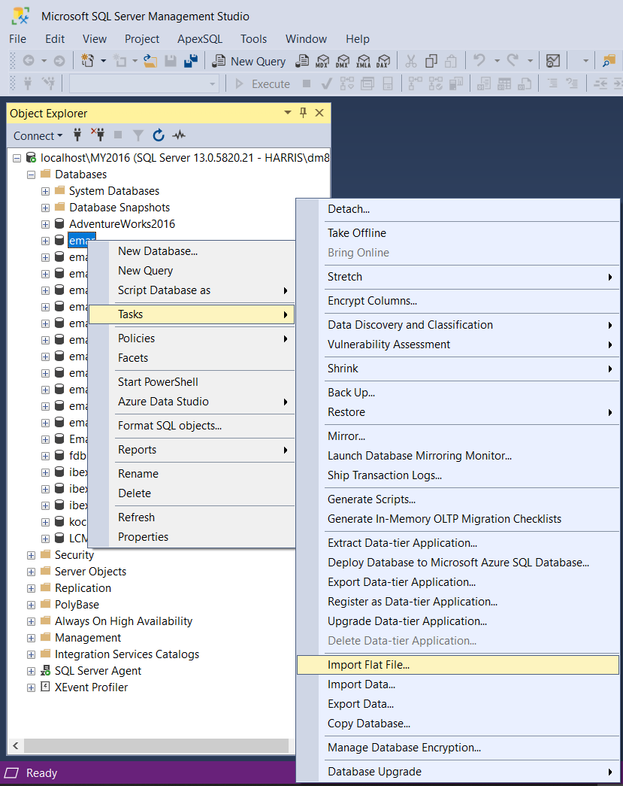
Screen #3
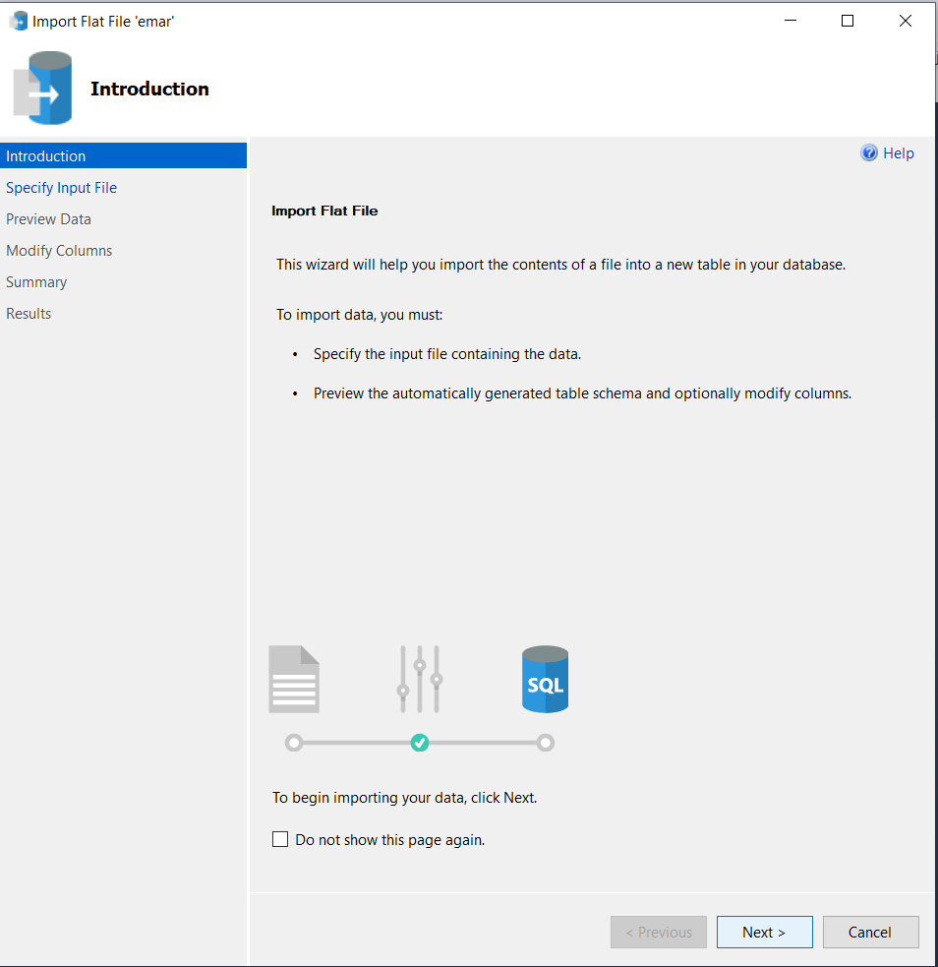
Screen #4
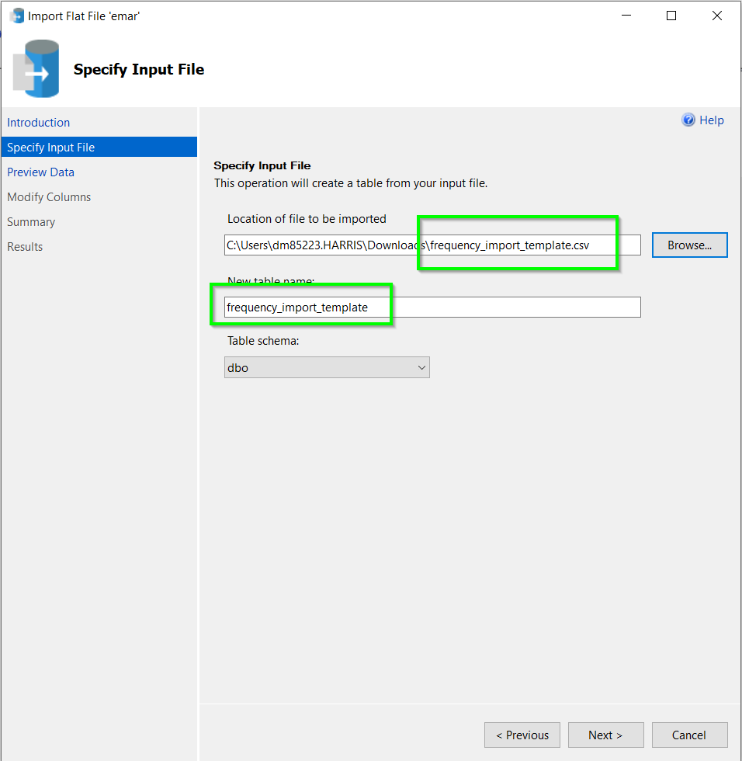
Screen #5
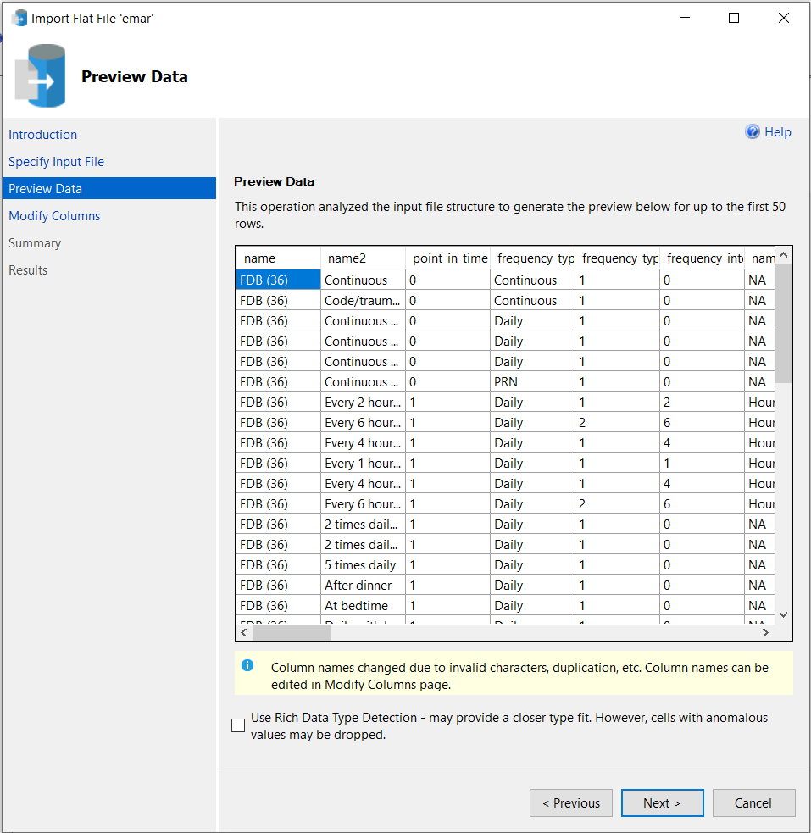
Screen #6
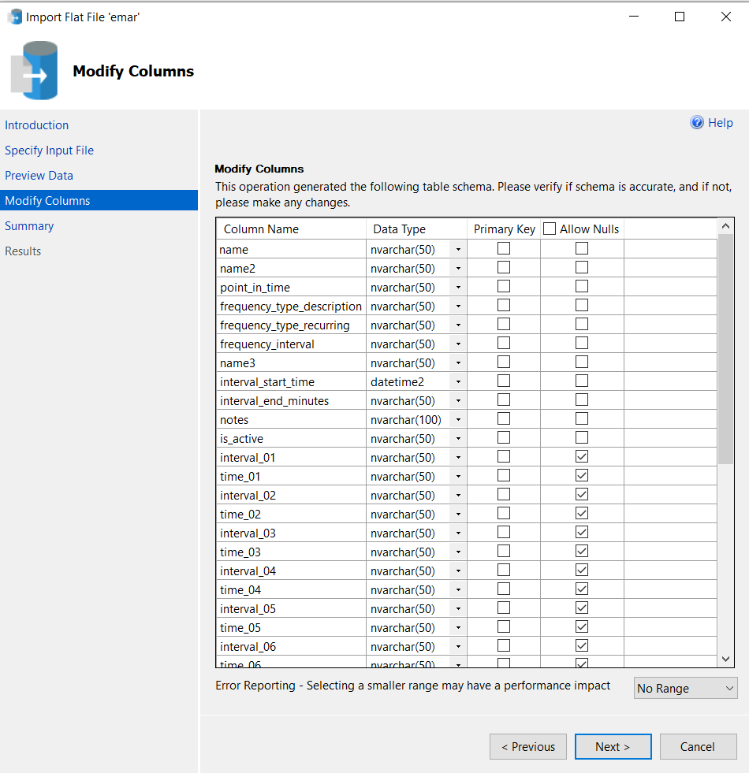
Screen #7
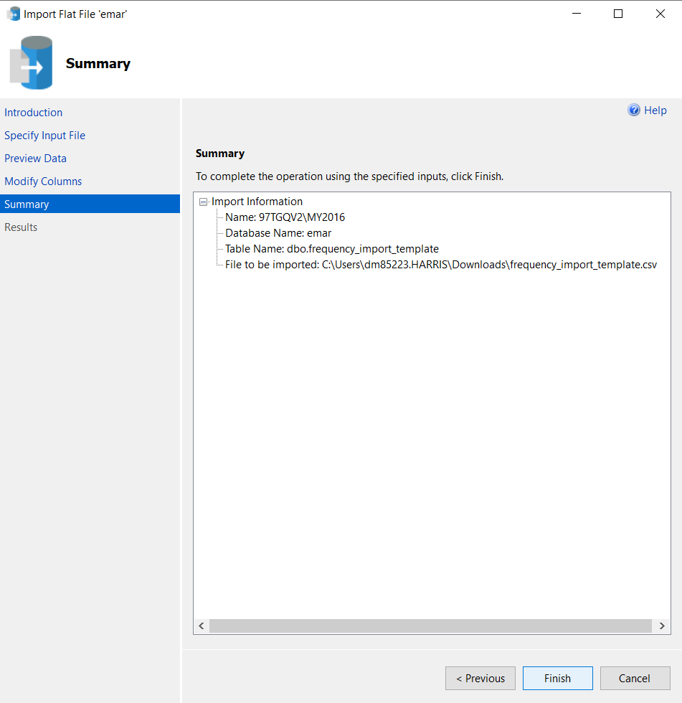
Screen #8
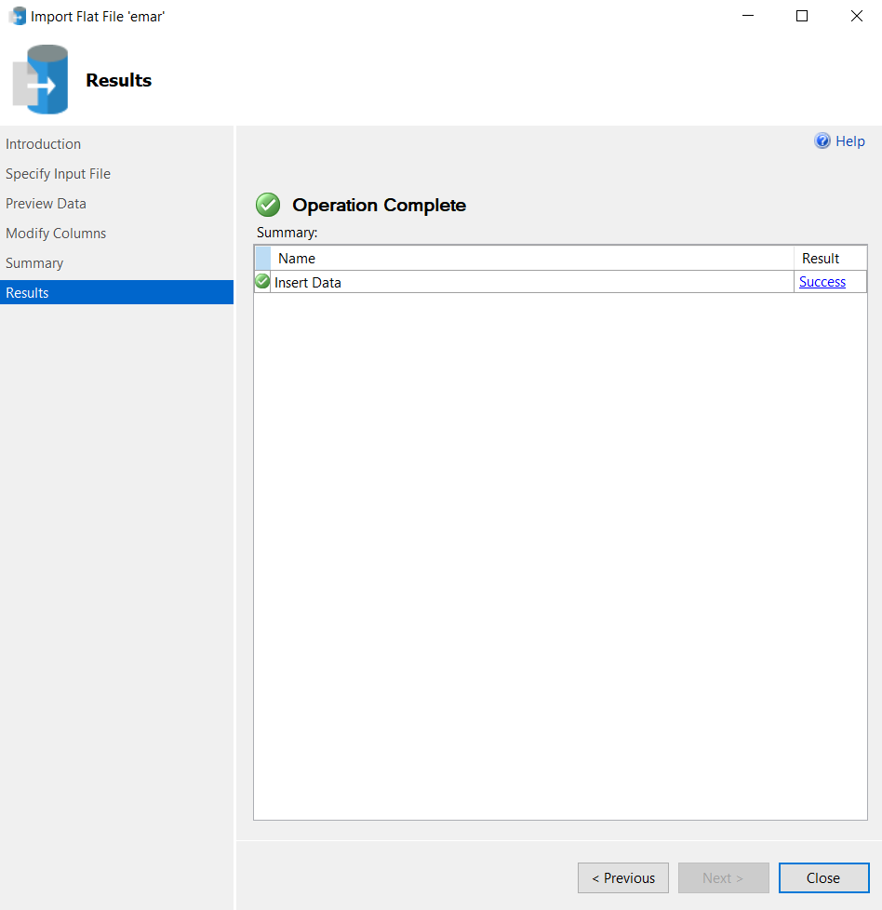
Screen #9
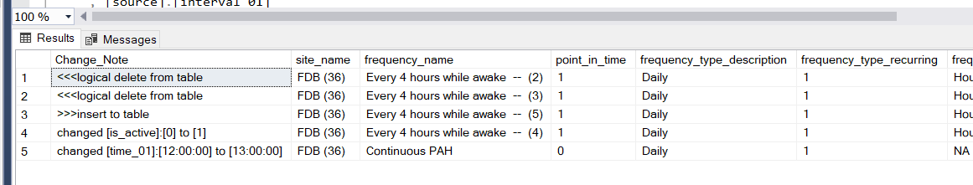

Screen #10
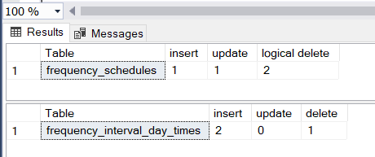

Screen #11
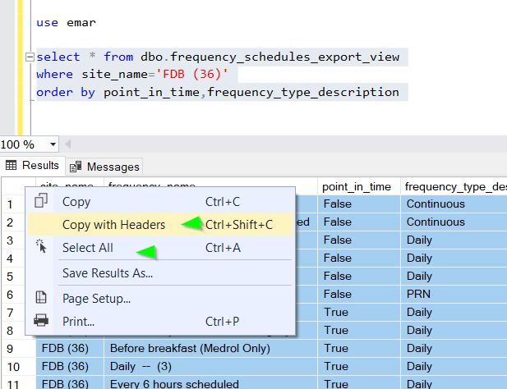

Screen #12
